Q1. What is this button called? | 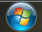
- start

Q2. What is the difference between left-mouse-click and right-mouse-click?
- Left is to open
- Right is for tools

Q3. What happens when you press CTRL and ALT and DEL together at the same time?
Computer turns off

 | A B C D E
Q4. What do these cursors mean? | 
- Normal cursor
- select
- type
- loading
- error
Q5. Label the diagram given below:
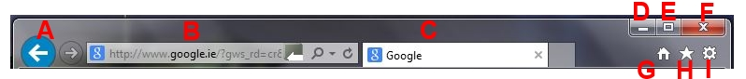
A - back
B – search bar
C - tab
D – minimise screen
E – maximise screen
F - close
G – home page
H – favourites/history
I -tools

